ANGULAR LEARNING

isolate scope with:

scope:{} isoliert jedes Element

scope:{

attribute: '@', //used to access string values that are defined outside the directive.

//it won’t keep changes made in the directive in-sync with the external/outer scope.

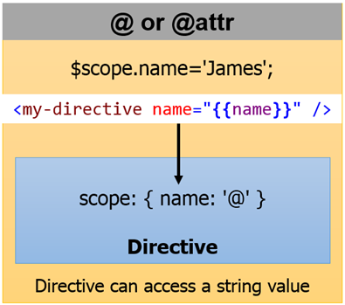

attribute: '=', //Two way binding. When one Model changes the other will also be changed

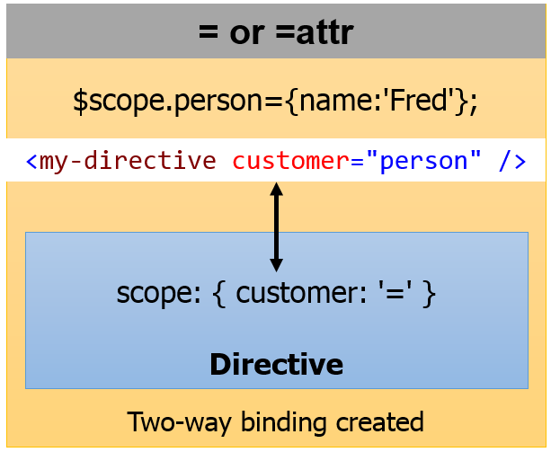

attribute: ‘&’ //used to bind to external functions (Good Tutorial: <https://egghead.io/lessons/angularjs-isolate-scope-> expression-binding)

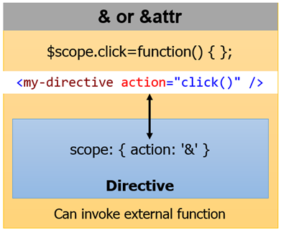

}

Angular JS-install

Then we’ll go to the command line and run the following command to install the tools of Yeoman:

npm install -g yo grunt-cli bower

Oh, and don’t forget, we’re going to use the AngularJS generator so you’ll need to install it as well:

npm install -g generator-angular

All we need to do is create our new project folder, navigate to it and run:

yo angular

Now, since we’re going to be using Jasmine, let’s add the karma-jasmine adapter to our project:

npm install karma-jasmine --save-dev

In case we want our tests to be executed on a Chrome instance, let’s also add the karma-chrome-launcher:

npm install karma-chrome-launcher --save-dev

To install angular materials

bower install angular-material

bower install angular-material --sav